**Bank Management System**

**Design Document**

**V 2.0**

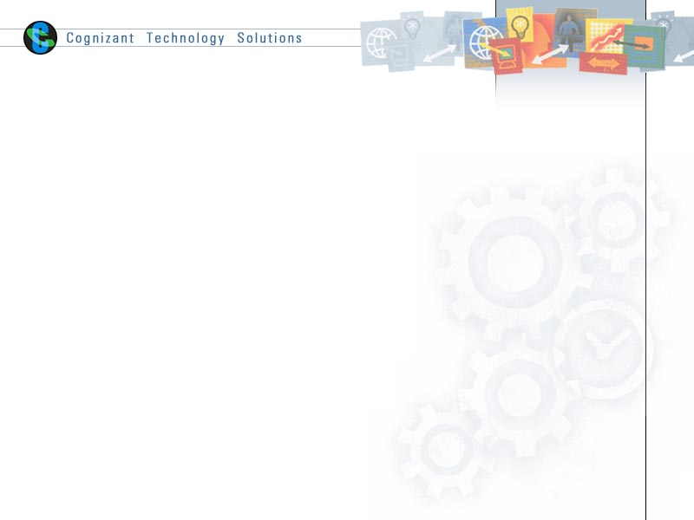

Table of Contents

1.0 Introduction 4

1.1 Purpose of this document 4

1.2 Project Overview 4

1.3 Intended Audience 4

1.4 Definition & Acronyms 4

1.5 References 4

2.0 Conventions and Standards Followed 5

3.0 Assumptions, Dependencies, and Risks 5

4.0 Use Case Realization 6

4.1 Flow of Events – Design 6

4.1.1 Perform Transaction 6

4.1.2 View Transaction 6

4.1.3 Apply Home Loan 7

4.1.5 Get Home Loan Details 7

4.1.6 Apply Education Loan 8

4.1.7 View Education Loan Details 8

4.2 UI Control 9

4.2.1 Perform Transactions 9

4.2.2 View Transaction Search Screen 9

4.2.3 View Transactions Results Screen 9

4.2.4 Apply Home Loan 10

4.2.5 Get Home Loan Search Screen 10

4.2.6 Get Home Loan Details Results Screen 10

4.2.7 Apply Education Loan 11

4.2.8 Get Education Loan Search Details 12

4.2.9 Get Education Loan Result Details 12

4.3 Class Diagrams – Design 13

4.3.1 Perform Transaction 13

4.3.2 View Transaction 13

4.3.3 Apply Home Loan 14

4.3.4 Get Home Loan Details 15

4.3.5 Apply Education Loan 16

4.3.6 Get Education Loan Details 17

4.4 Component Description 18

4.4.1 Perform Transaction 18

4.4.2 View Transaction 18

4.4.3 Apply Home Loan 19

5.0 Database Design 21

5.1 E- R Diagram (Relationship between Tables) 21

5.2 Data Design 22

6.0 Resource Traceability Matrix 23

7.0 Change Log 23

# Introduction

## Purpose of this document

The purpose of this Design Document is to specify the user about the application design to perform the transactions.

## Project Overview

This document illustrates the functional specification of the Bank Management System (BMS) application. BMS is a system used for managing the activities of bank like performing transaction, view Transactions, apply loan and get loan details.

The following are the three modules in the system-

1. Transaction Module
   1. Perform Transactions
   2. View Transactions
2. Home Loan Module
   1. Apply Home Loan
   2. Get Home Loan details
3. Educational Loan Module
   1. Apply Educational Loan
   2. Get Educational Loan details

## Intended Audience

* All associates going for the Integrated Assessments
* Customers, Business analysts, Testing team and Project Manager, Mentor Manager and trainer.

## Definition & Acronyms

N/A

## References

SystemRequirementDocument_BankingManagementSystem_v2.0.doc

# Conventions and Standards Followed

Bank Management System will follow Oracle and Java coding standard.

**

# Assumptions, Dependencies, and Risks

**Assumptions**

* Fields given in UI are matching skeleton and Design documents. Small mismatches can be ignored.

**Dependencies**

* Development Environment availability
* Review and Sign off

**Risk**

* Any delay in obtaining the sign-off for the design would have an impact in the schedule of the project.

# Use Case Realization

## Flow of Events – Design

### Perform Transaction

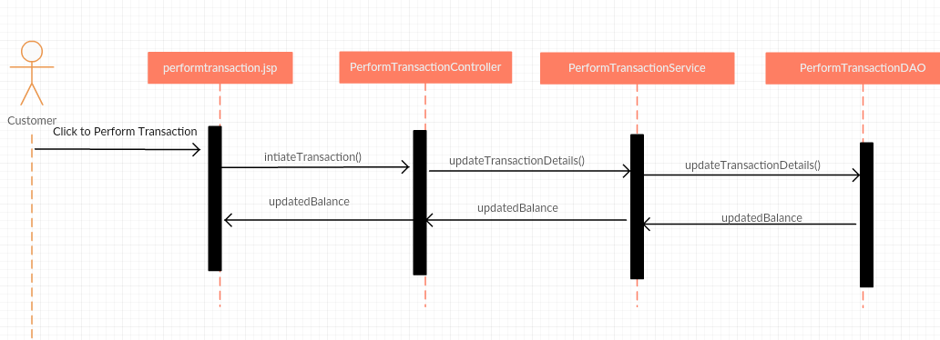

### View Transaction

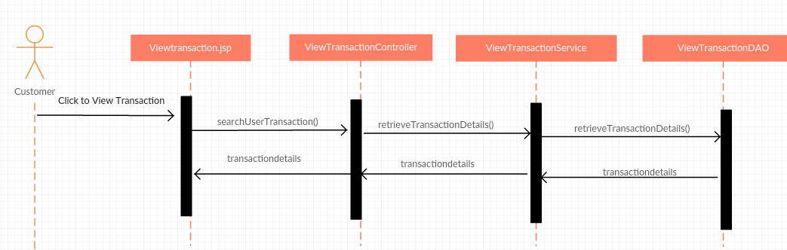

### Apply Home Loan

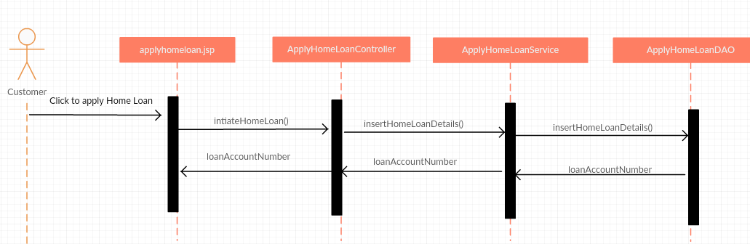

### Get Home Loan Details

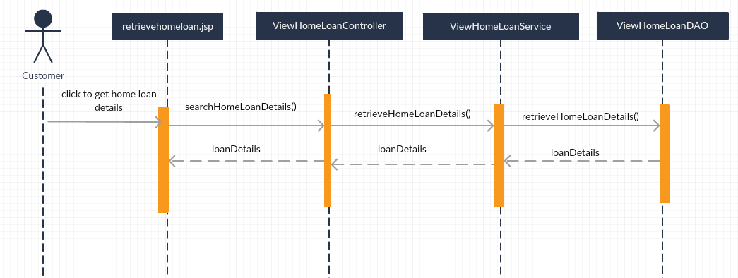

### Apply Education Loan

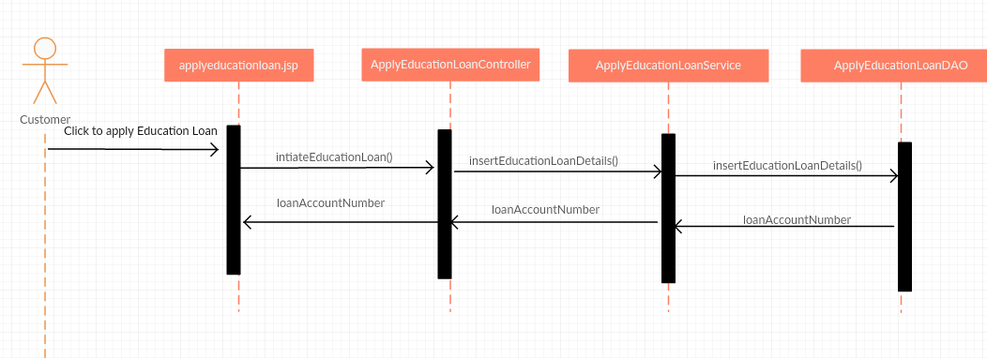

### View Education Loan Details

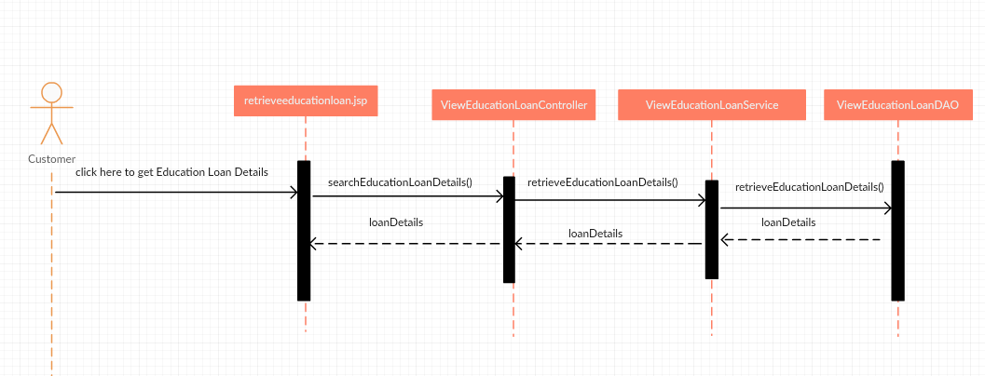

## UI Control

### Perform Transactions

|  |  |  |  |  |  |  |  |
| --- | --- | --- | --- | --- | --- | --- | --- |
| **Data Element** | **Control type** | **Default Values** | **Editable Field** | **Restriction** | **Mandatory/Not Mandatory** | **Data Type** | **Data Size** |
| Account Number | Textbox | No | Yes | Account number should be 16 digits | Mandatory | Number | 16 |
| Transaction Id | Textbox | No | Yes | Should be auto generated | Not Applicable | Number | 10 |
| Transaction Type | Dropdown List | None | Yes | Should have only two values – Deposit/Withdrawal | Mandatory | Varchar2 | 10 |
| Transaction Amount | Textbox | No | Yes | Should be numeric | Mandatory | Number | 20 |
| Description | TextArea | NO | Yes | Transaction Description cannot be empty | Not Mandatory | Varchar2 | 20 |
| Submit | Button | No | No | No | Mandatory | Button Type |  |

### View Transaction Search Screen

|  |  |  |  |  |  |  |  |
| --- | --- | --- | --- | --- | --- | --- | --- |
| **Data Element** | **Control type** | **Default Values** | **Editable Field** | **Restriction** | **Mandatory/Not Mandatory** | **Data Type** | **Data Size** |
| Account Number | Textbox | No | Yes | Account number should be 16 digits | At least one field from these needs to be entered | Number | 16 |
| Transaction Id | Textbox | No | Yes | Transaction id should be 10 digits | Number | 10 |
| View | Button | No | No | No | Mandatory | Button Type | Button |

### View Transactions Results Screen

|  |  |  |
| --- | --- | --- |
| **Data Element** | **Data Type** | **Data Size** |
| Account Number | Number | 16 |
| Transaction Id | Number | 10 |
| Transaction Type | Varchar2 | 10 |
| Description | Varchar2 | 20 |
| Balance | Number | 20 |

Transaction results should be displayed in Tabular format as shown below:

|  |  |  |  |  |
| --- | --- | --- | --- | --- |
| **Account Number** | **Transaction Id** | **Transaction Type** | **Description** | **Balance** |

### Apply Home Loan

|  |  |  |  |  |  |  |  |
| --- | --- | --- | --- | --- | --- | --- | --- |
| **Data Element** | **Control type** | **Default Values** | **Editable Field** | **Restriction** | **Mandatory/Not Mandatory** | **Data Type** | **Data Size** |
| Account Number | Textbox | No | Yes | Account number should be 16 digits | Mandatory | Number | 16 |
| Loan Amount | Textbox | No | Yes |  | Mandatory | Number | 16 |
| Loan Apply Date | Textbox | No | Yes | Loan Apply date should not be lesser than System date | Mandatory | Date |  |
| Loan Duration | Drop Down list | No | Yes | Values can be only 5,10,15,20 years | Mandatory | Number | 2 |
| Annual Income | Textbox | No | Yes | NA | Mandatory | Number | 16 |
| Company Name | Textbox | No | Yes | NA | Mandatory | Varchar | 30 |
| Designation | Textbox | No | Yes | NA | Mandatory | Varchar | 30 |
| Total Experience | Textbox | No | Yes | NA | Mandatory | Number | 2 |
| Experience with Current Company | Textbox | No | Yes | NA | Mandatory | Number | 2 |
| Submit | Button | No | No | NA | Mandatory | Button Type |  |

### Get Home Loan Search Screen

|  |  |  |  |  |  |  |  |
| --- | --- | --- | --- | --- | --- | --- | --- |
| **Data Element** | **Control type** | **Default Values** | **Editable Field** | **Restriction** | **Mandatory/Not Mandatory** | **Data Type** | **Data Size** |
| Loan Id | Textbox | No | Yes | Loan Id should be in format ‘HL-XXX’. XXX numeric of 3 digits. | At least one field from these needs to be entered | Varchar | 16 |
| Loan Account Number | Textbox | No | Yes | Account number should be 16 digits | Number | 20 |
| Get Loan Details | Button | No | No | No | Mandatory | Button Type | Button |

### Get Home Loan Details Results Screen

|  |  |  |
| --- | --- | --- |
| **Data Element** | **Data Type** | **Data Size** |
| Loan Account Number | Number | 16 |
| Account Holder Name | Varchar2 | 10 |
| Loan Id | Varchar2 | 16 |
| Loan Amount | Number | 16 |
| Desgination | Varchar2 | 30 |
| Company Name | Varchar2 | 30 |

Loan details should be displayed in Tabular format as shown below:

|  |  |  |  |  |  |
| --- | --- | --- | --- | --- | --- |
| Loan Account Number | Account Holder Name | Loan Id | Loan Amount | Desgination | Company Name |

### Apply Education Loan

|  |  |  |  |  |  |  |  |
| --- | --- | --- | --- | --- | --- | --- | --- |
| **Data Element** | **Control type** | **Default Values** | **Editable Field** | **Restriction** | **Mandatory/Not Mandatory** | **Data Type** | **Data Size** |
| Account Number | Textbox | No | Yes | Account number should be 16 digits | Mandatory | Number | 16 |
| Loan Amount | Textbox | No | Yes |  | Mandatory | Number | 16 |
| Loan Apply Date | Textbox | No | Yes | Loan Apply date should not be lesser than System date | Mandatory | Date |  |
| Loan Duration | Drop Down list | No | Yes | Values can be only 5,10 years | Mandatory | Number | 2 |
| Course Name | Textbox | No | Yes | NA | Mandatory | Varchar | 20 |
| Course Fee | Textbox | No | Yes | NA | Mandatory | Number | 16 |
| Father Name | Textbox | No | Yes | NA | Mandatory | Varchar | 20 |
| Id Number | Textbox | No | Yes | NA | Mandatory | Number | 16 |
| Father’s Annual Income | Textbox | No | Yes | NA | Mandatory | Number | 16 |
| Submit | Button | No | No | NA | Mandatory | Button Type |  |

### Get Education Loan Search Details

|  |  |  |  |  |  |  |  |
| --- | --- | --- | --- | --- | --- | --- | --- |
| **Data Element** | **Control type** | **Default Values** | **Editable Field** | **Restriction** | **Mandatory/Not Mandatory** | **Data Type** | **Data Size** |
| Identification Card Number | Textbox | No | Yes | Loan Id should be in format ‘EL-XXXXX’. XXXXX numeric of 5 digits. | At least one field from these needs to be entered | Varchar | 16 |
| Loan Account Number | Textbox | No | Yes | Account number should be 16 digits | Number | 20 |
| Get Loan Details | Button | No | No | No | Mandatory | Button Type | Button |

### Get Education Loan Result Details

|  |  |  |
| --- | --- | --- |
| **Data Element** | **Data Type** | **Data Size** |
| Account holder name | Varchar2 | 10 |
| Loan Id | Varchar2 | 16 |
| Loan Amount | Number | 16 |
| Course Name | Varchar2 | 20 |
| Desgination | Varchar2 | 30 |
| Father Name | Varchar2 | 20 |

Transaction results should be displayed in Tabular format as shown below:

|  |  |  |  |  |  |
| --- | --- | --- | --- | --- | --- |
| Loan Id | Account Holder Name | Loan Amount | Course Name | Desgination | Father Name |

## Class Diagrams – Design

### Perform Transaction

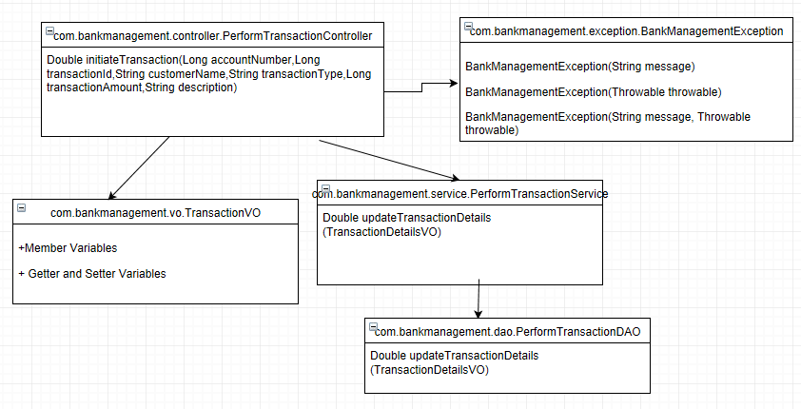

### View Transaction

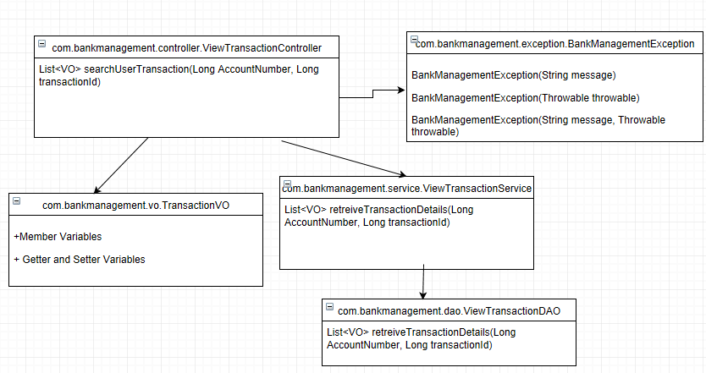

### Apply Home Loan

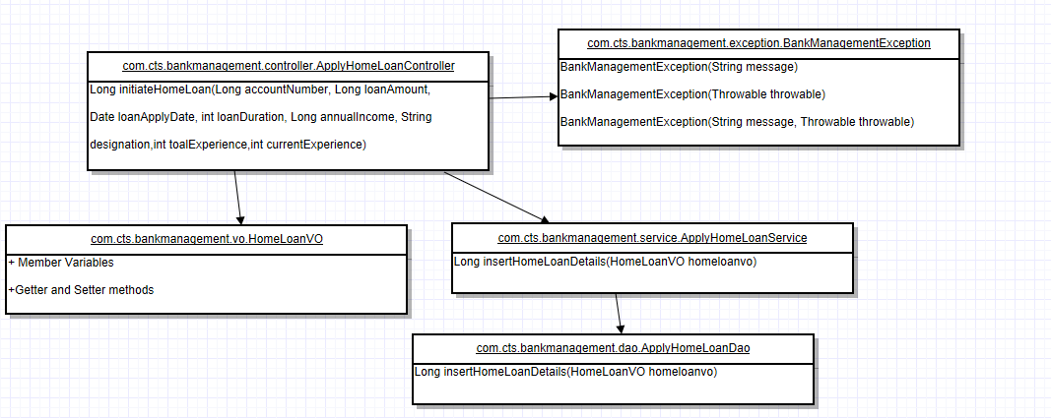

### Get Home Loan Details

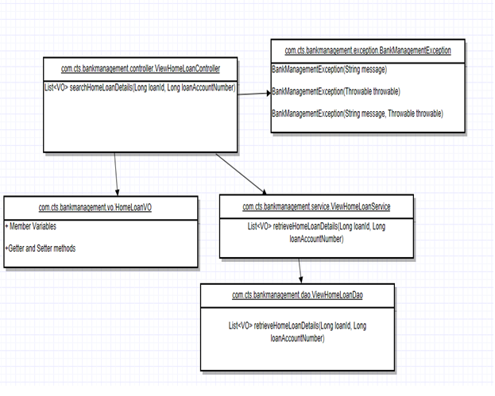

### Apply Education Loan

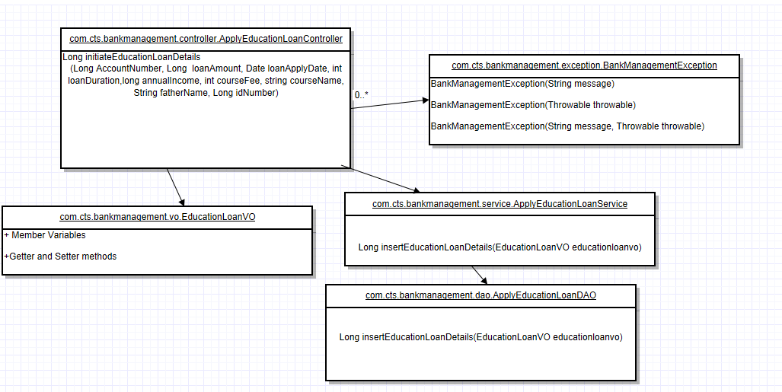

### Get Education Loan Details

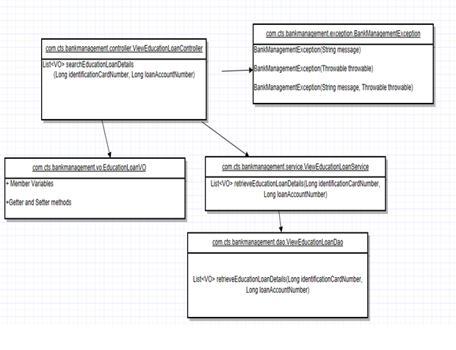

## Component Description

### Perform Transaction

|  |  |
| --- | --- |
| **Class** | **Method** |
| PerformTransactionController | **initiateTransaction ()**  **Parameters:** Long Account number, Long transaction id, String customer name, String transaction type, Long transaction amount, String description.  **Return Type:** Double |
| PerformTransactionService | **updateTransactionDetails()**  **Parameters:** TransactionDetailsVO  **Return Type:** Double |
| PerformTransactionDAO | **updateTransactionDetails ()**  **Parameters:** TransactionDetailsVO  **Return Type:** Double |

### View Transaction

|  |  |
| --- | --- |
| **Class** | **Method** |
| ViewTransactionController | **searchUserTransaction ()**  **Parameters:** Long AccountNumber, Long TransactionId  **Return Type:** List<VO> |
| ViewTransactionService | **retrieveTransactionDetails()**  **Parameters:** Long AccountNumber, Long TransactionId  **Return Type:** List<VO> |
| ViewTransactionDAO | **retrieveTransactionDetails ()**  **Parameters:** Long AccountNumber, Long TransactionId  **Return Type:** List<VO> |

### 4.4.3 Apply Home Loan

|  |  |
| --- | --- |
| **Class** | **Method** |
| ApplyHomeLoanController | **initiateHomeLoan ()**  **Parameters:** Long AccountNumber, Long loanAmount, Date loanApplyDate, intloanDuration, long annualIncome, String designation, int totalExperience, int currentExperience  **Return Type:** Long |
| ApplyHomeLoanService | **insertHomeLoanDetails()**  **Parameters:** homeloanVO  **Return Type:** Long |
| ApplyHomeLoanDAO | **insertHomeLoanDetails()**  **Parameters:** homeloanVO  **Return Type:** Long |

**4.4.4 Get Home Loan Details**

|  |  |
| --- | --- |
| **Class** | **Method** |
| ViewHomeLoanController | **searchHomeLoanDetails ()**  **Parameters:** Long AccountNumber, Long LoanId  **Return Type:** List<VO> |
| ViewHomeLoanService | **retrieveHomeLoanDetails()**  **Parameters:** Long AccountNumber, Long LoanId  **Return Type:** List<VO> |
| ViewHomeLoanDAO | **retrieveHomeLoanDetails()**  **Parameters:** Long AccountNumber, Long LoanId  **Return Type:** List<VO> |

**4.4.5 Apply Home Loan**

|  |  |
| --- | --- |
| **Class** | **Method** |
| ApplyEducationLoanController | **initiateEducationLoan ()**  **Parameters:** Long AccountNumber, Long loanAmount, Date loanApplyDate, int loanDuration, long annualIncome, int courseFee, string courseName, String fatherName, Long idNumber  **Return Type:** Long |
| ApplyEducationLoanService | **insertEducationLoanDetails()**  **Parameters:** educationloanVO  **Return Type:** Long |
| ApplyEducationLoanDAO | **insertEducationLoanDetails()**  **Parameters:** educationloanVO  **Return Type:** Long |

**4.4.6 Get Education Loan Details**

|  |  |
| --- | --- |
| **Class** | **Method** |
| ViewEducationLoanController | **searchEducationLoanDetails ()**  **Parameters:** Long AccountNumber, Long identificationCardNumber  **Return Type:** List<VO> |
| ViewEducationLoanService | **retrieveEducationLoanDetails()**  **Parameters:** Long AccountNumber, Long identificationCardNumber  **Return Type:** List<VO> |
| ViewEducationLoanDAO | **retrieveEducationLoanDetails()**  **Parameters:** Long AccountNumber, Long identificationCardNumber  **Return Type:** List<VO> |

# Database Design

## E- R Diagram (Relationship between Tables)

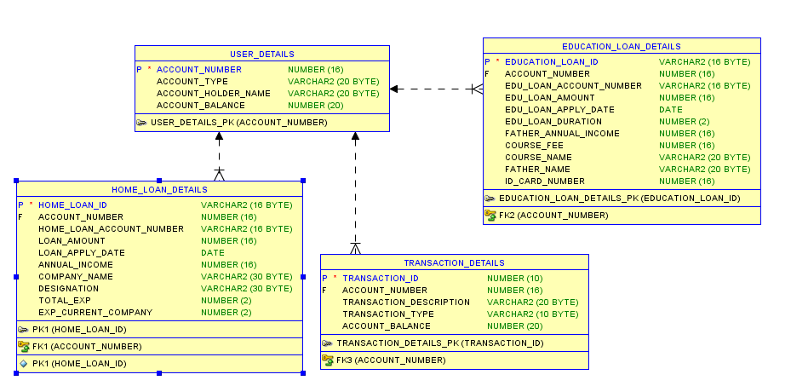

## Data Design

**USER_DETAILS Table**

|  |  |  |
| --- | --- | --- |
| Column Name | Column Type | Description |
| ACCOUNT_NUMBER | NUMBER(16) | Primary Key |
| ACCOUNT_TYPE | VARCHAR2(20) |  |
| ACCOUNT_HOLDER_NAME | VARCHAR2(20) |  |
| ACCOUNT_BALANCE | NUMBER(20) |  |

**TRANSACTION_DETAILS Table**

|  |  |  |
| --- | --- | --- |
| Column Name | Column Type | Description |
| TRANSACTION_ID | NUMBER(10) | Primary Key |
| TRANSACTION_DESCRIPTION | VARCHAR2(20) |  |
| TRANSACTION_TYPE | VARCHAR2(10) |  |
| ACCOUNT_NUMBER | NUMBER(16) | Foreign key |
| ACCOUNT_BALANCE | NUMBER(20) |  |

**HOME_LOAN_DETAILS Table**

|  |  |  |
| --- | --- | --- |
| Column Name | Column Type | Description |
| HOME_LOAN_ID | VARCHAR2(16) | Primary Key |
| ACCOUNT_NUMBER | VARCHAR2(16) | Foreign key |
| HOME_LOAN_ACCOUNT_NUMBER | VARCHAR2(16) |  |
| LOAN_AMOUNT | NUMBER(16) |  |
| LOAN_APPLY_DATE | DATE |  |
| LOAN_DURATION | NUMBER(2) |  |
| ANNUAL_INCOME | NUMBER(16) |  |
| COMP_NAME | VARCHAR2(30) |  |
| DESIGNATION | VARCHAR2(30) |  |
| TOTAL_EXP | NUMBER(2) |  |
| EXP_CURRENT_COMP | NUMBER(2) |  |

**EDUCATION_LOAN_DETAILS Table**

|  |  |  |
| --- | --- | --- |
| Column Name | Column Type | Description |
| EDUCATION_LOAN_ID | VARCHAR2(16) | Primary Key |
| ACCOUNT_NUMBER | VARCHAR2(16) | Foreign key |
| EDU_LOAN_ACCOUNT_NUMBER | VARCHAR2(16) |  |
| EDU_LOAN_AMOUNT | NUMBER(16) |  |
| EDU_LOAN_APPLY_DATE | DATE |  |
| EDU_LOAN_DURATION | NUMBER(2) |  |
| FATHER_ANNUAL_INCOME | NUMBER(16) |  |
| FATHER_NAME | VARCHAR2(20) |  |
| COURSE_FEE | NUMBER(16) |  |
| COURSE_NAME | VARCHAR2(20) |  |
| ID_CARD_NUMBER | NUMBER(16) |  |

# Resource Traceability Matrix

N/A

# Change Log

|  |  |
| --- | --- |
| Version Number | Changes made |
| V 1.0 | *Bank Management System V 1.0* |
|  |  |